



Build and Test an AI Data Processing Pipeline Using PyTest
LAB MANUAL

Disclaimer: The content is curated from online/offline resources and used for educational purpose only
Build and Test an AI Data Processing Pipeline Using PyTest
Objective:
- Build a modular tabular data cleaning and feature engineering pipeline for machine learning ingestion.
- Implement automated unit and integration tests using PyTest to validate schema constraints, missing-value strategies, and normalization bounds.
- Apply PyTest fixtures for consistent mock data provisioning and parametrization to test multiple transformation scenarios without repetitive code.
Problem statement:
Machine learning models often degrade in performance or crash entirely because of unhandled upstream data defects, including unexpected null entries, non-standard text formats, out-of-bounds numerical outliers, and schema drift. Standard runtime errors rarely catch subtle numerical bugs (such as improper scaling or incorrect imputation means).
You are required to build a modular preprocessing module that cleans noisy text strings, imputes missing numerical values through multiple strategies, and applies standard feature scaling. You must then write an automated PyTest suite employing fixtures and parametrization to thoroughly validate component transformations, edge cases, and type safety before data reaches training routines.
Materials/ Equipment needed:
- Computer running Linux, macOS, or Windows.
- Python 3.10 or higher.
- Terminal / Command Line Interface.
- Python packages: pytest, pandas, numpy, scikit-learn.
- Code editor.
Prerequirties knowldege:
- Familiarity with Pandas DataFrames and NumPy array operations.
- Understanding of standard data preprocessing techniques (imputation, string sanitization, feature scaling).
- Basic knowledge of writing Python assertions and executing commands in a terminal.
Theory:
In Machine Learning Operations (MLOps), automated testing of data preprocessing pipelines prevents garbage-in, garbage-out failure modes. Because data transformations are functional mappings from one distribution or format to another, tests must verify mathematical boundaries, output shapes, and edge-case exceptions.
PyTest simplifies this testing process through two primary constructs:
- Fixtures (@pytest.fixture): Reusable helper functions that construct baseline mock datasets, database handles, or pipeline configurations before tests run. This eliminates boilerplate setup code across test functions and ensures each test starts with an unmutated state.
- Parametrization (@pytest.mark.parametrize): A decorator that feeds multiple distinct input-output pairs into a single test function. In ML pipelines, parametrization allows you to evaluate multiple imputation strategies (mean, median), diverse dirty-string variants, and boundary-value outliers within a single test block.
Procedure:
Step 1: Set Up Project Workspace and Virtual Environment
Open your terminal, create a project directory named ai_pipeline_pytest, initialize an isolated Python virtual environment, and install pytest, pandas, numpy, and scikit-learn. Configuring an isolated environment isolates these package versions from other projects, while installing these specific libraries provides both the tabular manipulation stack and the automated testing framework needed for the pipeline.
mkdir ai_pipeline_pytest
cd ai_pipeline_pytest
python3 -m venv venv
source venv/bin/activate
pip install pytest pandas numpy scikit-learn

Step 2: Construct Modular Directory Structure
Create separate directories for the pipeline source code (src/) and automated test suites (tests/), along with package initializer files. Separating the production processing logic from the test definitions follows standard repository standards, ensuring that PyTest automatically discovers tests while keeping production build artifacts clean.
On linux you can execute the below to create the folder structure:
mkdir src tests
touch src/__init__.py tests/__init__.py
touch src/pipeline.py tests/test_pipeline.py

On windows you can create the folder structure manually as give below:
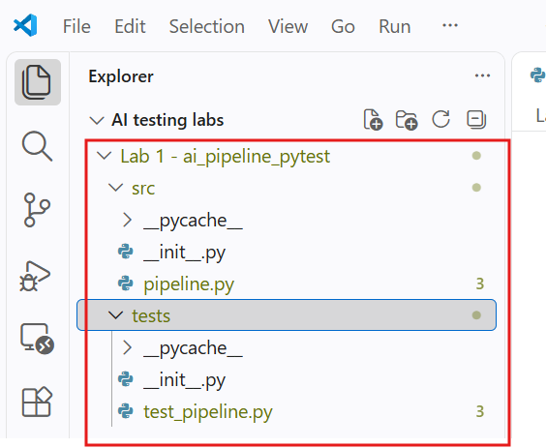
Step 3: Implement the Data Preprocessing Pipeline Module
Open src/pipeline.py and write functions to normalize string columns, impute missing values using configurable strategies, and scale numerical features using scikit-learn. Writing isolated, single-responsibility functions makes individual steps of the ML data pipeline modular, allowing each transformation to be tested, modified, or swapped independently without side effects.
import pandas as pd
import numpy as np
from sklearn.preprocessing import StandardScaler
from typing import List

def clean_text_column(series: pd.Series) -> pd.Series:
"""Trim whitespace, strip non-alphanumeric noise, and convert text to lowercase."""
if not isinstance(series, pd.Series):
raise TypeError("Input must be a pandas Series.")
return series.astype(str).str.strip().str.lower()

def impute_missing_numeric(df: pd.DataFrame, column: str, strategy: str = "mean") -> pd.DataFrame:
"""Impute missing numerical entries using either mean or median strategy."""
if column not in df.columns:
raise KeyError(f"Column '{column}' does not exist in the DataFrame.")

df_copy = df.copy()
if strategy == "mean":
fill_val = df_copy[column].mean()
elif strategy == "median":
fill_val = df_copy[column].median()
else:
raise ValueError("Strategy must be either 'mean' or 'median'.")

df_copy[column] = df_copy[column].fillna(fill_val)
return df_copy

def scale_numeric_features(df: pd.DataFrame, feature_cols: List[str]) -> np.ndarray:
"""Standardize numerical columns to zero mean and unit variance."""
for col in feature_cols:
if col not in df.columns:
raise KeyError(f"Feature column '{col}' missing from DataFrame.")
if df[col].isnull().any():
raise ValueError(f"Column '{col}' contains NaN values. Impute before scaling.")

scaler = StandardScaler()
return scaler.fit_transform(df[feature_cols])

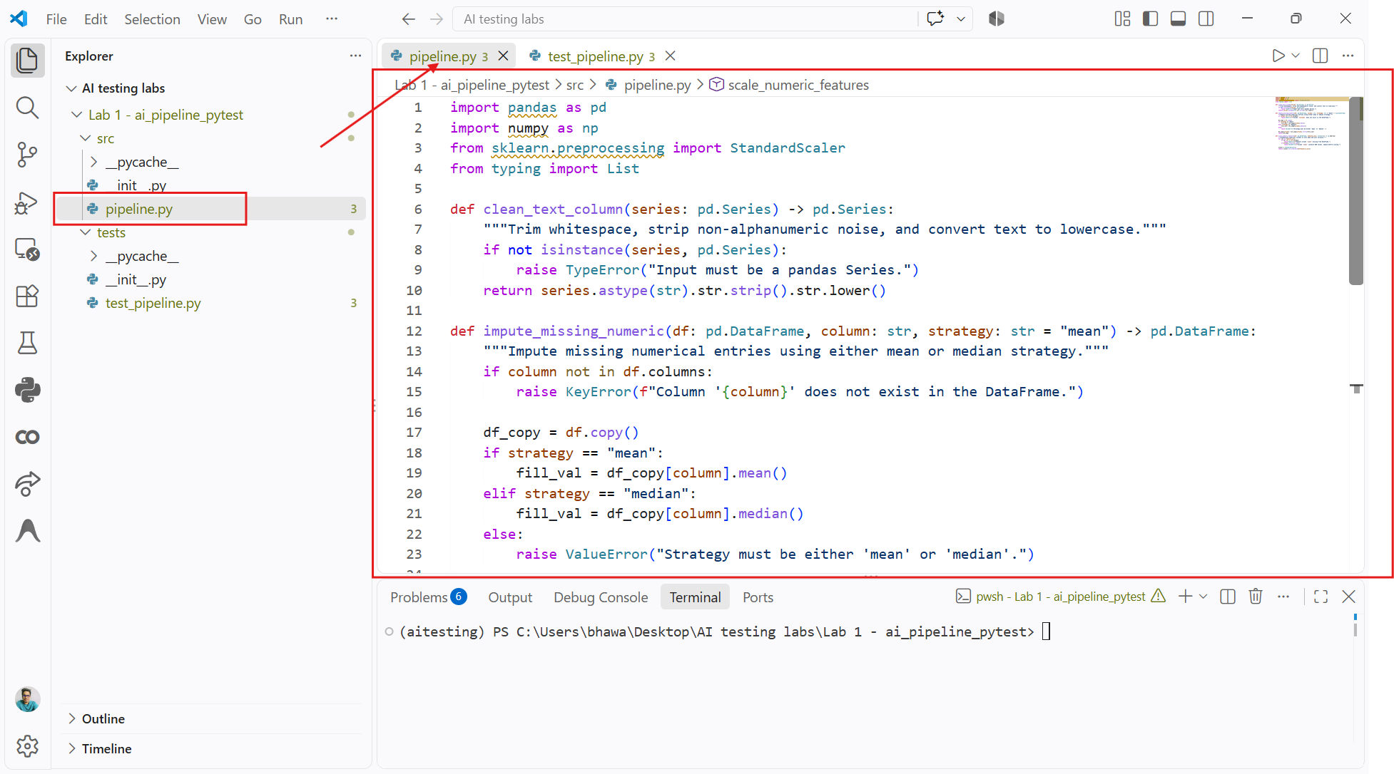

Step 4: Build Automated PyTest Suites with Fixtures and Parametrization
Open tests/test_pipeline.py and write unit tests that utilize a shared PyTest fixture for synthetic data and use @pytest.mark.parametrize to evaluate multiple imputation algorithms and text sanitization cases. Using fixtures ensures a consistent baseline dataset across all test cases without code duplication, while parameterized tests thoroughly exercise transformations against dirty data variants, invalid parameters, and edge-case exceptions.
import pytest
import pandas as pd
import numpy as np
from src.pipeline import clean_text_column, impute_missing_numeric, scale_numeric_features

@pytest.fixture
def raw_dataset():
"""Provides a synthetic tabular dataset simulating uncleaned customer records."""
return pd.DataFrame({
"customer_name": [" ALICE ", "Bob", " Charlie ", "david"],
"account_balance": [1000.0, np.nan, 3000.0, 4000.0],
"credit_score": [650.0, 700.0, 750.0, np.nan]
})

@pytest.mark.parametrize("input_series, expected_values", [
(pd.Series([" Data ", "SCIENCE", " ai "]), ["data", "science", "ai"]),
(pd.Series(["TEST", "TeSt ", " test"]), ["test", "test", "test"])
])
def test_clean_text_column_variations(input_series, expected_values):
"""Ensure text sanitization handles varying whitespace and capitalization correctly."""
result = clean_text_column(input_series)
assert result.tolist() == expected_values

def test_clean_text_type_check():
"""Verify that passing invalid types raises a TypeError."""
with pytest.raises(TypeError, match="Input must be a pandas Series"):
clean_text_column(["invalid", "list", "input"])

@pytest.mark.parametrize("strategy, expected_imputed_value", [
("mean", 2666.6667), # (1000 + 3000 + 4000) / 3
("median", 3000.0) # Median of [1000, 3000, 4000]
])
def test_impute_missing_numeric_strategies(raw_dataset, strategy, expected_imputed_value):
"""Verify that numeric imputation adheres to the selected statistical strategy."""
imputed_df = impute_missing_numeric(raw_dataset, "account_balance", strategy=strategy)

assert imputed_df["account_balance"].isnull().sum() == 0
assert np.isclose(imputed_df["account_balance"].iloc[1], expected_imputed_value, atol=1e-4)

def test_impute_invalid_strategy(raw_dataset):
"""Ensure unsupported imputation strategies raise a ValueError."""
with pytest.raises(ValueError, match="Strategy must be either 'mean' or 'median'"):
impute_missing_numeric(raw_dataset, "account_balance", strategy="mode")

def test_scale_features_unhandled_nulls(raw_dataset):
"""Ensure scaling fails early with a clear ValueError if missing values are present."""
with pytest.raises(ValueError, match="contains NaN values"):
scale_numeric_features(raw_dataset, ["account_balance"])

def test_scale_features_success(raw_dataset):
"""Verify standard scaling converts clean numeric features to mean=0 and std=1."""
# Pre-clean dataset using pipeline functions
df_imputed = impute_missing_numeric(raw_dataset, "account_balance", strategy="mean")
df_imputed = impute_missing_numeric(df_imputed, "credit_score", strategy="mean")

scaled_array = scale_numeric_features(df_imputed, ["account_balance", "credit_score"])

assert scaled_array.shape == (4, 2)
assert np.allclose(scaled_array.mean(axis=0), [0.0, 0.0], atol=1e-7)
assert np.allclose(scaled_array.std(axis=0), [1.0, 1.0], atol=1e-7)
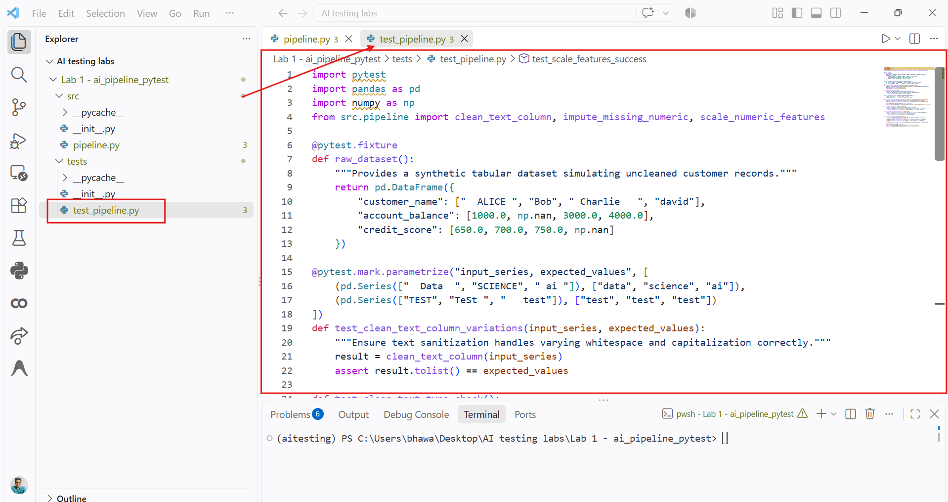
Step 5: Run the Test Suite and Analyze Pipeline Validation Coverage Execute PyTest from the root directory with verbose reporting (pytest -v -s). Running this command invokes the test runner, discovers all parameterized variations and fixture dependencies, and verifies that string cleaning, statistical imputation, and scaling components pass their assertions without errors.
pytest -v -s tests/test_pipeline.py
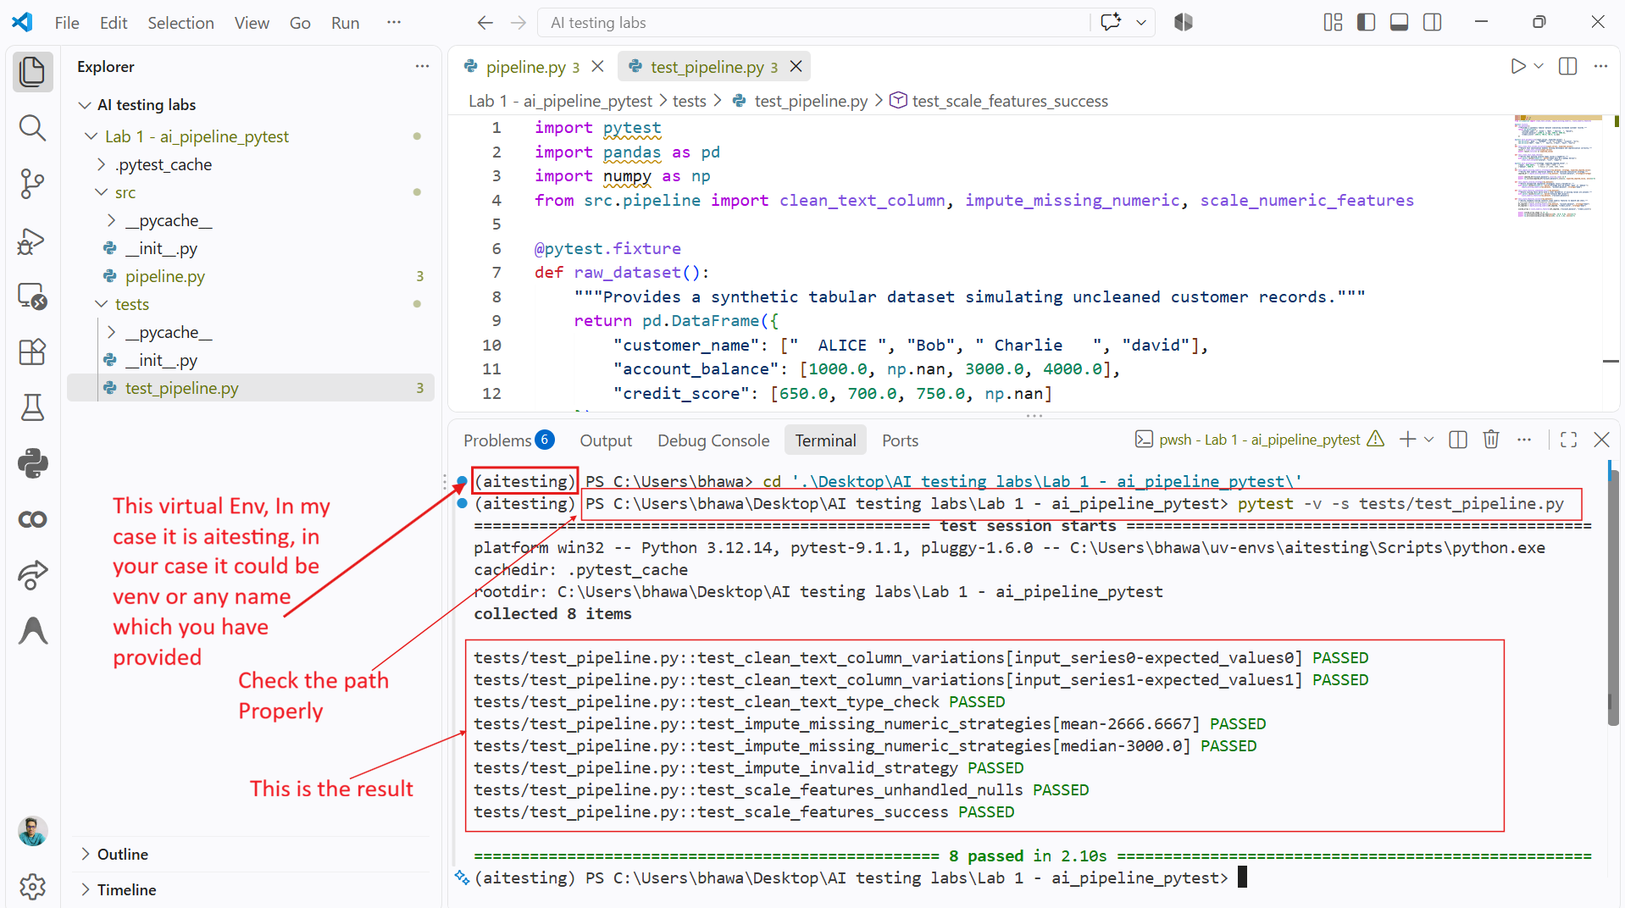

Conclusion:
In this lab, you built an automated testing suite for an AI data processing pipeline using PyTest. By separating data transformations into modular functions, you ensured that text cleaning, missing-value imputation, and feature scaling can be verified independently. Using PyTest fixtures provided clean, isolated mock datasets across tests, and parameterized test cases verified that multiple transformation strategies and invalid inputs were handled safely. This automated testing workflow ensures that downstream ML models receive statistically sound, schema-compliant data.

